**LAB # 03 NETWORK CABLE AND CONNECTORS**

1. **OBJECTIVE**

To make following UTP Cables

1. Straight through Cable

2. Cross Cable

2. **THEORY**

Twisted pair cables have different types and categories. Some of its types are given below:

1) STP (shielded Twisted Pair)

2) UTP (Un-shielded Twisted Pair)

3) ScSTP (Screened Shielded twisted pair can also come under STP type)

There are around 7 categories of Twisted pair these categories are defined on the basis of data rates and their usage

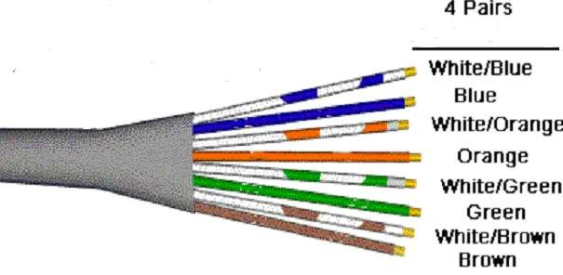

3. **CONNECTORS**

**Figure 1. Wires**

The straight through and crossover patch cables discussed in this article are terminated with CAT 5 RJ-45 modular plugs. RJ-45 plugs are similar to those you'll see on the end of your telephone cable except they have eight versus four or six contacts on the end of the plug and they are about twice as big. Make sure they are rated for CAT 5 wiring. (RJ means "Registered Jack"). Also, there are RJ-45 plugs designed for both solid core wire and stranded wire. Others are designed specifically for one kind of wire or the other. Be sure you buy plugs appropriate for the wire you are going to us

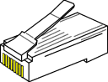

**Figure 2. RJ-45 Connector**

4. **NETWORK CABLE TOOLS**

**Modular Plug Crimp Tool**: You will need a modular crimp tool. This one is very similar to the one that can be used for all kinds of telephone cable work and it works just fine for Ethernet cables. You don't need a lot of bells and whistles, just a tool which will securely crimp RJ-45 connectors. Even though the crimper has cutters which can be used to cut the cable and individual wires, and possibly stripping the outer jacket.

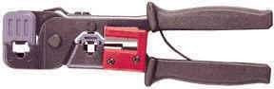

**Figure 3. Modular Plug Crimp Tool**

**Universal UTP Stripping Tool (Eclipse):** It makes a much Neater cut. I recommended that you purchase one if you will be making many cables.

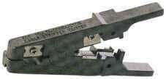

**Figure 4. Eclipse**

**Diagonal Cutters** ("4 to 6"): It is easier to use diagonal cutters ("diags" or "dikes") to cut the cable off at the reel and to fine tune the cable ends during assembly. Also, if you don't have a stripper, you can strip the cable by using a small knife (X-acto, utility, etc.) to carefully slice the outer jacket longitudinally and use the diags to cut it off around the circumferenc

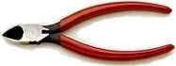

**Figure 5. Diagonal Cutters**

5. **BASIC THEORY**

The 10BASE-T and 100BASE-TX Ethernets consist of two transmission lines. Each transmission line is a pair of twisted wires. One pair receives data signals and the other pair transmits data signals. A balanced line driver or transmitter is at one end of one of these lines and a line receiver is at the other end. A (much) simplified schematic for one of these lines and its transmitter and receiver follow:

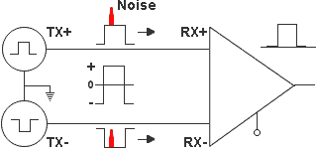

**Figure 6. Schematic Diagram of transmission line**

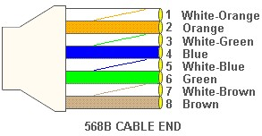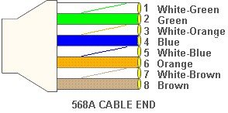

**Figure 7. 568A Figure 8. 568B**

|  |  |
| --- | --- |
| PIN | CABLE COLOR |
| 1 | White/Orange |
| 2 | Orange |
| 3 | White/Green |
| 4 | Blue |
| 5 | White/Blue |
| 6 | Green |
| 7 | White/Brown |
| 8 | Brown |

**Table 1**

Now, all you need to remember, to properly configure the cables, are the diagrams for the two cable ends and the following rules:

**A straight-through cable has identical ends.** For straight through cable following wire configuration is used on both the sides

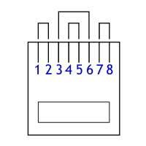

**Figure 9. RJ-45 Plug with clip facing down**

**A crossover cable has different ends.** It makes no functional difference which standard you use for a straight-thru cable. You can start a crossover cable with either standard as long as the other end is the other standard. It makes no functional difference which end is which. Despite what you may have read elsewhere, a 568A patch cable will work in a network with 568B wiring and 568B patch cable will work in a 568A network. The electrons couldn't care less.

|  |  |
| --- | --- |
| PIN | CABLE COLOR |
| 1 | White/Green |
| 2 | Green |
| 3 | White/Orange |
| 4 | Blue |
| 5 | White/Blue |
| 6 | Orange |
| 7 | White/Brown |
| 8 | Brown |

|  |  |
| --- | --- |
| PIN | CABLE COLOR |
| 1 | White/Orange |
| 2 | Orange |
| 3 | White/Green |
| 4 | Blue |
| 5 | White/Blue |
| 6 | Green |
| 7 | White/Brown |
| 8 | Brown |

**Table 2 Table 4**

One End of Cable Other End of Same Cable



**Figure 10 Figure 1**

**Do it Yourself**

**TO MAKE CABLE**

1. Pull the cable off the reel to the desired length and cut. The total length of wire segments between a PC and a hub or between two PC's cannot exceed 100 Meters (328 feet or about the length of a football field) for 100BASE-TX and 300 Meters for 10BASE-T.

2. Strip one end of the cable with the stripper or a knife and diags. If you are using the stripper, place the cable in the groove on the blade (left) side of the stripper and align the end of the cable with the right side of the stripper. This will strip about 1/2" of the jacket off the cable. Turn the stripper about 1 1/4 turns and pull.

If you turn it more, you will probably nick the wires. If you are using a knife and diags, carefully slit the cable for about an inch or so and neatly trim around the circumference of the cable with diags to remove the jacket.

3. Inspect the wires for nicks. Cut off the end and start over if you see any. You may have to adjust the blade with the screw at the front stripper. Cable diameters and jacket thicknesses vary.

4. Spread and arrange the pairs roughly in the order of the desired cable end.

• Untwist the pairs and arrange the wires in the order of the desired cable end.

• Flatten the end between your thumb and forefinger. Trim the ends of the wires so they are even with one another.

• **It is very important that the unstripped (untwisted) end be slightly less than 1/2" long.**

• If it is longer than 1/2" it will be out-of-spec and susceptible to crosstalk.

• If it less than slightly less than 1/2" it will not be properly clinched when RJ-45 plug is crimped on.. Flatten again. There should be little or no space between the wires.

5. Hold the RJ-45 plug with the clip facing down or away from you. Push the wire firmly into the plug. **Now**, **inspect before crimping and wasting the plug!** Looking through the bottom of the plug, the wire on the far left side will have a white background. The wires should alternate light and dark from left to right. The furthest right wire is brown. The wires should all end evenly at the front of the plug. The jacket should end just about where you see it in the diagram below

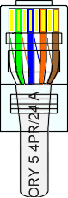

**ALL ABOUT CRIMPING**

6. Hold The Wire Near The Rj-45 Plug With The Clip Down And Firmly Push It Into The

Left Side Of The Front Of The Crimper (It Will Only Go In One Way).

Hold The Wire In Place Squeeze The Crimper Handles Quite Firmly. This Is What

Will Happen:

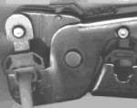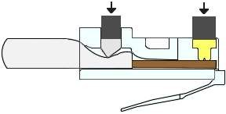

(Crimp it once.) The crimper pushes two plungers down on the RJ-45 plug. One forces what amounts to a cleverly designed plastic plug/wedge onto the cable jacket and very firmly clinches it.

The other seats the "pins," each with two teeth at its end, through the insulation and into the conductors of their respective wires.

7. Test the crimp... If done properly an average person will not be able to pull the plug off the cable with his or her bare hands. And that quite simply, besides lower cost, is the primary advantage of twisted-pair cables over the older thin wire, coaxial cables.

In fact, I would say the RJ-45 and ease of its installation is the main reason coaxial cable is no longer widely used for small Ethernets. But, don't pull that hard on the plug. It could stretch the cable and change its characteristics.

Look at the side of the plug and see if it looks like the diagram and give it a fairly firm tug to make sure it is crimped well.

8. Prepare the other end of the cable so it has the desired end and crimp.

9. If both ends of the cable are within reach, hold them next to each other and with RJ-45 clips facing away. Look through the bottom of the plugs. If the plugs are wired correctly, and they are identical, it is a straight-thru cable. If they are wired correctly and they are different, it is a crossover cable.

**CABLING RULES**

1. Try to avoid running cables parallel to power cables.

2. Do not bend cables to less than four times the diameter of the cable.

3. If you bundle a group of cables together with cable ties (zip ties), do not over-cinch them. It's okay to snug them together firmly; but don't tighten them so much that you deform the cables.

4. Keep cables away from devices which can introduce noise into them. Here's a short list: copy machines, electric heaters, speakers, printers, TV sets, fluorescent lights, copiers, welding machines, microwave ovens, telephones, fans, elevators motors, electric ovens, dryers, washing machines, and shop equipment.

5. Avoid stretching UTP cables (the force should not exceed 25 LBS).

6. Do not run UTP cable outside of a building. It presents a very dangerous lightning hazard!

7. Do not use a stapler to secure UTP cables. Use telephone wire hangers which are available at most hardware stores.

**ANSWER THE FOLLOWING**

1. Give the reason why it is not advisable to bend UTP cabled more than four times the diameter of the cable?

Ans: The bend applied on UTP cabled is 4 times the diameter of outer jacket. Otherwise, if bend increase then it will damage the cable and shorten its life by this user will be introduce loss due to effect.

1. Why is it not advisable to run UTP cable outside of a building?

Ans: Because these are “Unshielded” twisted pairs, outside the building it can be damaged during unfavorable weather condition cause multiple dangerous hazards.

1. Define the recommended maximum cable length for UTP and cite for it.

Ans: In general the length should not be more than 100 meters (328 ft) to avoid data loss.